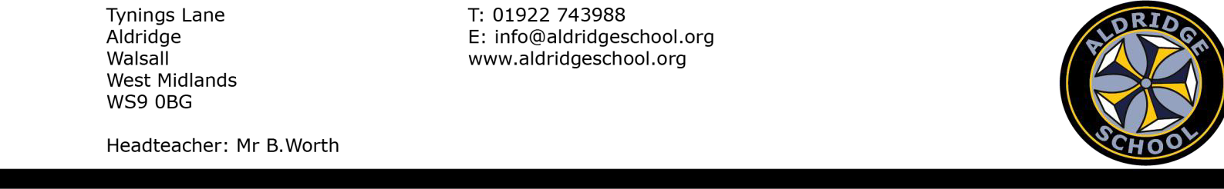

Application form for Music Scholarship September 2027
Child’s Name ....................................... Date of Birth ..........................

Parent/Guardian Name(s) ......................................................................

Address ..............................................................................................

.........................................................................................................

......................................................... Postcode...................................

Telephone Numbers

Daytime.............................................. Evening .................................

E mail address ……………………………………………………………………………… Please give the name and address of your child’s Junior School
.........................................................................................................
To apply for a place you must complete two forms
- Aldridge School Specialist Music Application form (this form) – to be returned to Aldridge School, by 31 October 2026.

AND

- Walsall Residents (where a child attends a Walsall Primary School) they should complete an online application by 31 October 2026. You must select Aldridge School Music scholarship place
Parents living outside Walsall must submit an application to their home authority.

- Music Information

First Instrument*..............................................................................................
(*Voice should be regarded as an instrument)

Name of present instrumental teacher .......................... Tel. No......................... Please give the approximate date when lessons were started..................................
Grade and mark of last exam: Grade: ...................... Mark: .............................. (please enclose copy of certificate)

Please state the examining board (i.e. Associated Board, Trinity College, London College or other)

......................................................................................................................

Please list below details of any other musical instrument your child plays and any exam details.

......................................................................................................................

……………………………………………………………………………………………………………………………………….

Please list the names of any orchestras, bands, or ensembles of which your child is a member

......................................................................................................................

......................................................................................................................

Does your child sing in a choir? YES/NO

If yes, what is the name of choir? ......................................................................

Give details of outside hobbies and interests which your child enjoys

......................................................................................................................

......................................................................................................................

......................................................................................................................

- The auditions will take place at Aldridge School on Saturdays during November and we will write to you giving details of the date and time.
The audition requires two contrasting pieces to be performed on the first instrument. Give details about the piece and the composer below. Candidates would often bring an accompanist with them where piano accompaniment is needed. A spare copy of the music is also required. Please send a photocopy with this application form. It is generally much better for accompaniments to be played unless the music is written to be unaccompanied.

If you require someone from Aldridge School Music Department to play for you please tick the box and send the music for the accompaniments along with this application form.

Accompanist needed

Piece No. 1

Title: ..................................................
Composer:...........................
Piece No. 2

Title: ..................................................
Composer:...........................

Please return this form to

Headteacher’s PA
Aldridge School, Tynings Lane, Aldridge, Walsall, WS9 OBG

TO REACH THE SCHOOL NO LATER THAN 31 OCTOBER 2026

ENCLOSURES REQUIRED: Certificate copies for verification
Music for audition
  - The part played by the candidate
  - Any piano accompaniment*

*you need not send an accompaniment if you are bringing an accompanist with you.

Name ............................................................. School ............................... Instrument......................................................

FOR EXAMINER’S USE ONLY

Piece No.1 .........................................

Piece No.2 .........................................

Sight Reading.....................................

Aural i)..............................................

ii).....................................................

- ....................................................

- ....................................................

Theory ..............................................

Total ...................................

...................................................................................................

...................................................................................................

...................................................................................................

...................................................................................................

...................................................................................................

...................................................................................................

